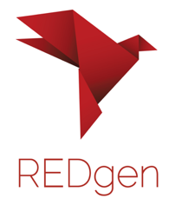

Dear Families,

Your student has taken a position of leadership within our school REDgen Chapter. REDgen is a local non-profit whose mission is to advocate for youth mental health and well-being through the lens of resiliency. REDgen supports communities in raising resilient youth who are living authentic lives with a strong sense of emotional well-being.

REDgen Schools is a peer to peer resiliency program designed to educate and empower student leaders to raise resiliency within their school community through connection, reflection and conversation.

Throughout the school year we will focus on 8 areas that foster resilience. Your student will dig into one area of resilience per month on a personal level and then engage as part of a team that advocates for resilience within the larger student body, staff and community as a whole.

For more information on REDgen, visit their website at www.redgenschool.org.
If you have any further questions, please reach out to me.

We are looking forward to a year of growth with your student.

Sincerely,

